FEMM Introduction Lab
Seth Ricks
ECEN 390
Brother Swenson
ECEN 390 - FEMM Introduction Lab (60 points)
(jas FEMM Introduction Lab.docx 10/23/2025)

Note: This is a CAD lab to be done individually, rather than in teams, although please help each other out if/when opportunities arise, avoiding plagiarism. Submit an electronic version of a lab report to receive credit for doing this lab. The goal of your lab report is to provide sufficient documentation so that others could re-create your results. Therefore, simply add to this document to arrive at your lab report, as all of the explanatory text, procedures and Discussion and Conclusion questions contained in this document are required for a complete lab report. So, for your lab report, add a cover page, your results, along with your answers to the Discussion and Conclusions questions to the existing lab document. Your answers to the Discussion and Conclusions questions are to be uniquely yours and not a copy of someone else’s answers to these questions. Your cover page is to include class, lab title, and author. A grading rubric for this lab is included at the end of this document. The rubric does not need to be included in your lab report.

Purpose: FEMM (Finite Element Method Magnetics) is a free Finite Element Analysis (FEA) software package for Windows. The purpose of this lab is to utilize FEMM for two Electrostatic problems.

Prior to using FEMM, watch the following video on Finite Element Analysis (FEA).
Finite Element Analysis for Beginners. (6:25).

Go to Finite Element Method Magnetics Home Page Download 64-bit Executable and install the software.

The steps required to simulate a given problem in FEMM are as follows:

- Specify the problem parameters which includes the problem type, length units coordinate system and materials.
- Define the geometric model and assign appropriate materials.
- Solve the problem and analyze the results.

Procedure:

Part 1 – Coaxial Cable

The cross-section of a coaxial cable is shown below in Figure 1, with dimension a being the radius of the inner conductor and dimension b being the distance from the center of the inner conductor to the outer shield. The gray area between conductors represents the insulator (dielectric) required to maintain dimension b during flexing of the cable, etc.

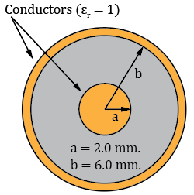
Figure 1: Cross-Section of a Coaxial Cable.

The following steps lead to the modeling and analysis of the coaxial cable shown in Figure 1 using FEMM>

Specify the Problem Parameters and Geometric Model

- After starting FEMM, open a new problem by means of File New Electrostatics Problem, resulting in the Electrostatics Model Development Window as shown below in Figure 2.
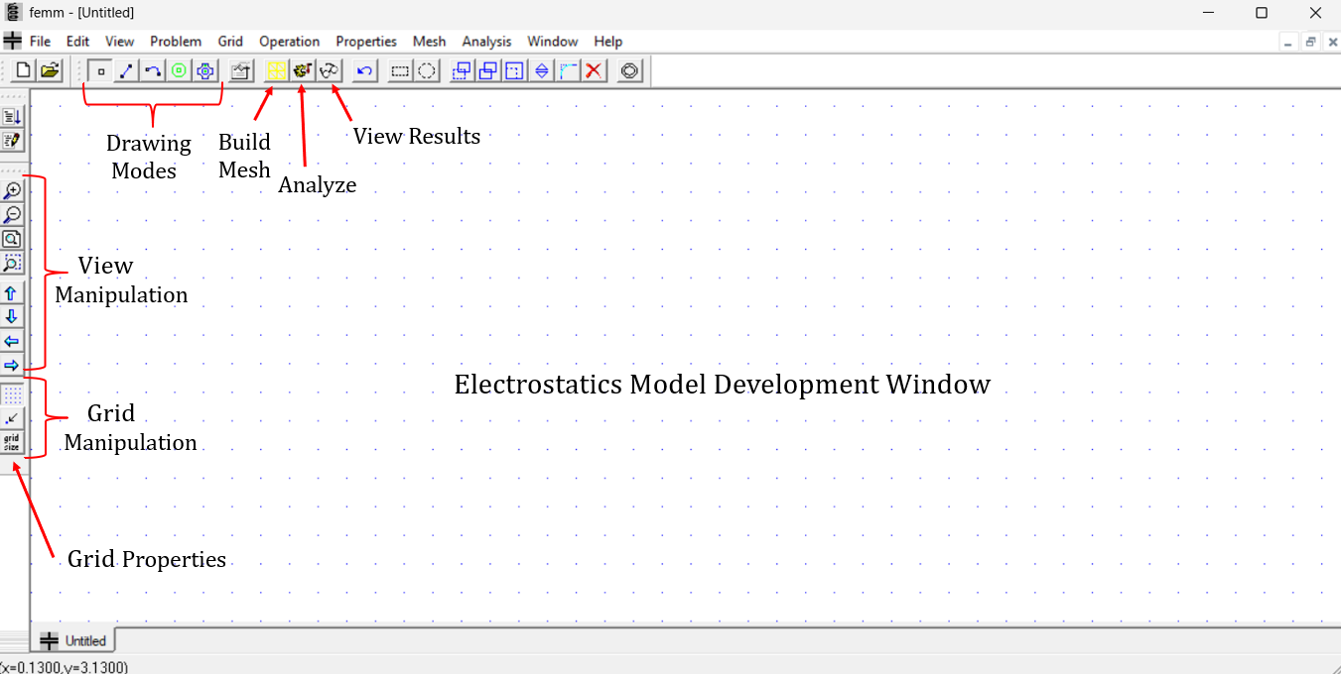
Figure 2: FEMM Electrostatics Model Development Window.

- Select Problem on the top toolbar to open the Problem Definition dialog box and verify/complete the following settings: Problem Type: Planar, Length Units: Millimeters, Depth: 1000, corresponding to 1 meter.
- Select Properties Materials Library to open some common materials for electrostatics properties. Find Teflon in the left-hand column and drag Teflon to the right-hand column representing the materials used for the coaxial cable.
- Select Properties Conductors to open the Circuit Property dialog box. Left click on Add Property to add a conductor. Name the conductor Inner Conductor, enable the Prescribed Voltage and set the voltage to 1 for 1 V. Repeat this process for the Outer Shield, with the Prescribed Voltage set to 0 for 0 V.
- Select the Point (node) drawing mode. The tab key provides an easy way to exactly locate points (nodes) via numeric entry of the x and y coordinates.
- Enter the following x-y point coordinates using the tab key: (2, 0), (0, 2), (-2, 0), (0, -2),
(6, 0), (0, 6), (-6, 0), (0, -6), (7, 0), (0, 7), (-7, 0), (0, -7). The points entered for the
outlines of the inner conductor and outer shield of a coaxial cable.
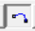
- Select Arc drawing mode.
- Traversing the points on the circles in a Counter-Clockwise direction, left mouse click on one point (node) then on the next point (node) to open the Arc segment properties dialog box. Set/verify the Arc Angle of 90˚, which is the angle traversed from the center of the circle from the first selected point (node) to the next. Join Arc Segments between points (nodes) to produce a 2-D coaxial cable cross section as illustrated below in Figure 3.
- Select the Point (node) drawing mode. Enter the following x-y point coordinate using the tab key: (0, 0). This point (node) is to be used as a contour endpoint in the upcoming analysis of the coaxial cable.
- Select the block drawing mode and then left mouse click inside each plate and the dielectric area to include block labels. Next right mouse click on each block label to select it, followed by pressing the keyboard space bar to open the Properties for selected block dialog box to assign the appropriate predefined material label, i.e., Inner Conductor, Teflon and Outer Shield to each block label shown below in Figure 3. 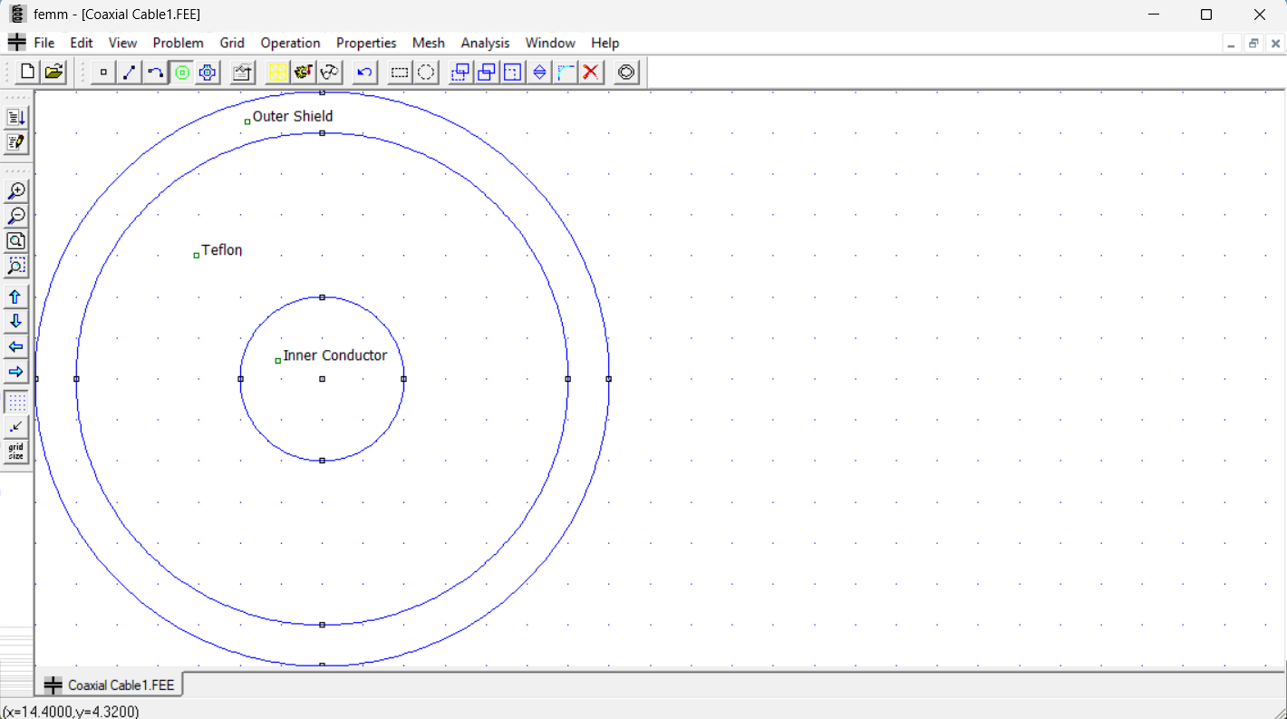
Figure 3: 2-D Coaxial Cable Geometric Model.

Solve the Problem and Analyze the Results

- Select Mesh Create Mesh, followed by solving the problem followed by Analysis Analyze, and Analysis View Results. Creating the mesh and analyzing the problem and viewing the results can also be accomplished by the icons. (Note: Inadvertently adding extra Block labels is easy to do when clicking around the model development window, which results in the error “Material properties have not been defined for all block labels. Cannot analyze the problem” when trying to simulate your model. One way to find these inadvertent Block labels so they can be deleted is to click on the Zoom extents icon to include all Block labels. )
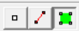
- Viewing the results produces a (Postprocessor) window with several analysis features. Like the drawing modes in the model development window, there are three modes in the analysis (Postprocessor) window, the Point Values mode, the Contour mode and the Block mode, corresponding to the icons, respectively. The Point Values mode provides analysis information at the current pointer location upon a left mouse click. The Contour mode provides parameter variation, such as voltage variation, along a defined contour. The Block mode defines areas and volumes that can be integrated to provide parameters such as total energy.
- From the top menu, select View Density Plot, which opens a dialog box. Check the Show Density Plot and Show Legend in the dialog box.
- From the top menu, select View Contour Plot, which opens a dialog box. Check the Show equipotential lines in the dialog box.
- Select View Vector Plot, which opens the Vector Plot Options dialog box. Choose Electric Field Intensity (E) as the vector to plot. The solution results should look like the results in Figure 4 below, with the contours representing equipotential lines and the arrows representing the Electric Field with longer lines corresponding to larger magnitudes.
- Click on the capacitor symbol on the top toolbar to open the Conductor Properties pane that includes the voltage and charge of all the defined conductors. Select the Inner Conductor to display the charge on the inner conductor for a voltage difference of 1 V between the inner conductor and shield. Based on the relationship Q = CV, the capacitance per unit length of the coaxial cable equals the charge when the applied voltage is 1 V.
- Take a screen shot of your FEMM Coaxial Cable Analysis (Postprocessor) Window that includes the Conductor Properties pane and annotate your name, which needs to be done outside of FEMM in an application like Power Point or Word, and then replace Figure 4 below with your version. (10 points.)
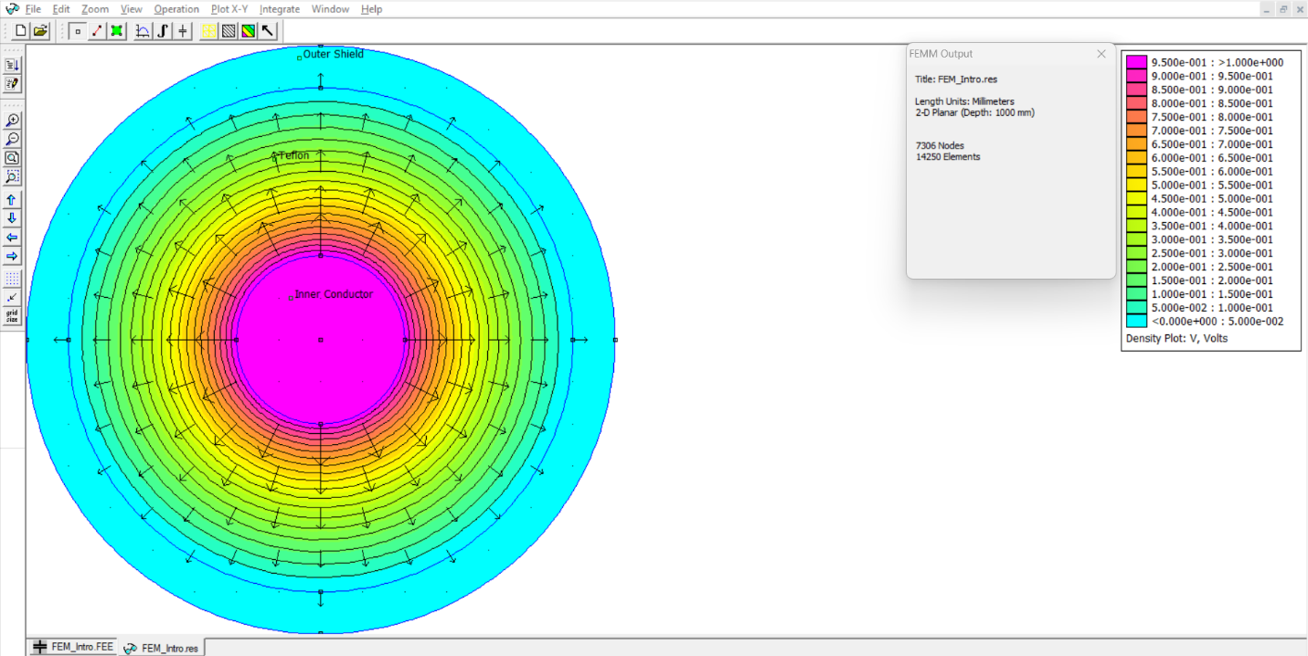
Seth Ricks
Figure 4: Annotated Coaxial Cable Analysis (Postprocessor) Window.

- Enable the Contour mode from the top toolbar and right mouse click on the center point (node) in the Inner Conductor and then right mouse click on the rightmost point (node) on the outer shield to form a line contour as denoted by a red line between the selected points. (The Escape key removes contour lines as needed.) Select the x-y Plot icon from the top toolbar to open the X-Y Plot of Field Values dialog box. Choose V (Voltage) as the Plot Type and check the Write data to text file option in the dialog box to save the x-y plot data for import into MATLAB. (Note: Do not include spaces in your text file name, as spaces in the filename are incompatible with the MATLAB file read functions.)
- Again, select the x-y Plot icon from the top toolbar and in the X-Y Plot of Field Values dialog box choose ∣E∣ (Magnitude of field intensity) and check the Write data to text file option.
- Next import your coaxial cable voltage and electric field magnitude data into MATLAB and produce a 2-pane subplot of your simulation results as shown below in Figure 5. The MATLAB readmatrix() function, along with appropriate options can read in your saved text files and ignore the first two lines of text header information.

opts = detectImportOptions('Coaxial_Cable_Voltage_Variation.txt');
opts.DataLines = [3 Inf]; % Start reading from line 3 onward
V_profile = readmatrix('Coaxial_Cable_Voltage_Variation.txt', opts);
MagE_profile = readmatrix('Coaxial_Cable_E_Magnitude_Variation.txt', opts);

- For the first subplot, i.e., subplot(2, 1, 1), plot the Voltage versus Distance from the Center of the Coaxial Cable, as shown below in Figure 5. For your first subplot, include an x-axis label of “Distance from the Center of the Coaxial Cable (mm)” using the xlabel() function. Include a y-axis label of “Voltage (V)” using the ylabel() function. Also add a title of “Voltage Profile with 1 V Difference Between the Inner Conductor and Shield – Your Name”. Add the following ylim([0, 1.2]) statement to scale the y-axis more favorably.
- For your second subplot, i.e., subplot(2, 1, 2), plot the Electric Field Magnitude versus Distance from the Center of the Coaxial Cable, as shown below in Figure 5.
- Include an x-axis label of “Distance from the Center of the Coaxial Cable (mm)”. Include a y-axis label of “Electric Field Magnitude (V/m)”. Also add a title of “Electric Field Magnitude Profile with 1 V Difference Between the Inner Conductor and Shield”. For the Electric Field Magnitude trace use a trace color different than the color used for the Voltage trace used in the first subplot. Add the following ylim([0, 500]) statement to scale the y-axis more favorably.
- In the MATLAB plot pane, Insert TextBox to insert a movable text box on each subplot that includes the dimensions a = 2.0 mm and b = 6.0 mm.
Replace Figure 5 below with your version. (10 Points.)
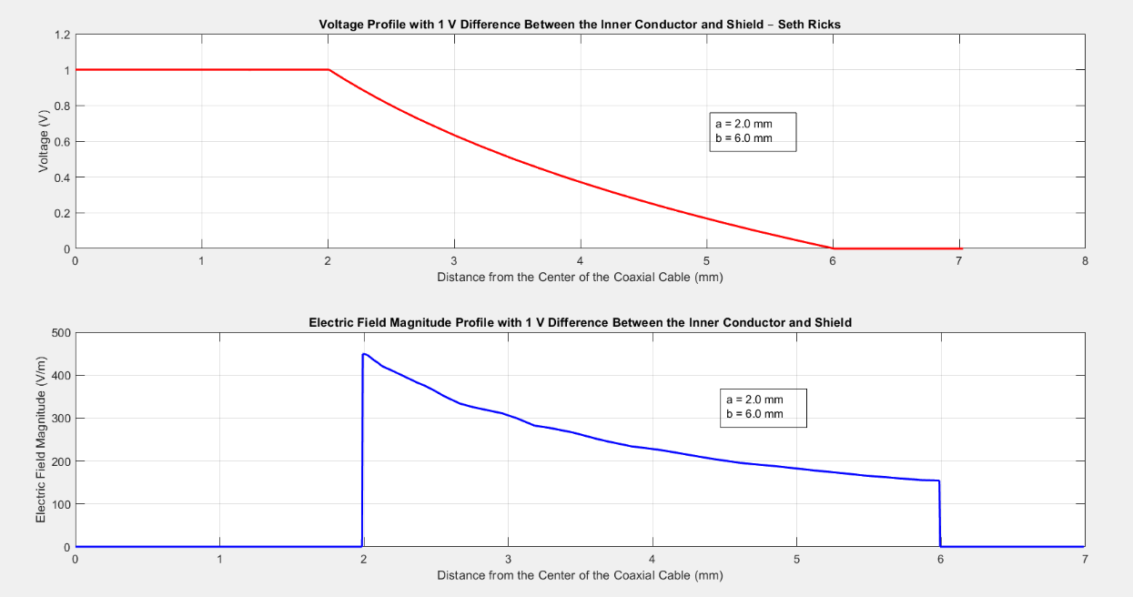
Figure 5: Coaxial Cable Voltage and Electric Field Magnitude Profiles.

Part 2 – Parallel Plate Capacitor

You are to next model a parallel plate capacitor in FEMM and plot voltage and electric field magnitude profiles between the plates. Additionally, the relative permittivity of the insulating dielectric will be varied to see the effects on the capacitance.

- Select File New Electrostatics Problem. and name the problem file something like Parallel Plate Capacitor1.
- Select Problem on the top toolbar to open the Problem Definition dialog box and verify/complete the following settings: Problem Type: Planar, Length Units: Millimeters, Depth: 10.
- Select Properties Materials opens the Property Definition dialog box. Click on Add Property and add Plate and Dielectric as material properties, both having a relative permittivity of 1, which applies for metal conductors and an air dielectric.
- Select Properties Conductors to open the Circuit Property dialog box. Left click on Add Property to add a conductor. Name the conductor Top Plate, enable the Prescribed Voltage and set the voltage to 1 for 1 V. Repeat this process for the Bottom Plate, with the Prescribed Voltage set to 0 for 0 V.
- Select the Point (node) drawing mode. The tab key provides an easy way to exactly locate points (nodes) via numeric entry of the x and y coordinates.
- Enter the following x-y point coordinates using the tab key: (1, 1), (11, 1), (1, 1.4), (11, 1.4), (1, 1.6), (11, 1.6), (1, 2.0), (11, 2.0).
- Select Segment drawing mode.
- Left mouse click on one point (node) then on the next point (node) to join a Line Segments between points (nodes) to produce a 2-D parallel plate capacitor with a plate area of 10 mm X 10 mm, a plate thickness of 0.4 mm and a plate spacing of 0.2 mm as illustrated below in Figure 6.
- Select the block drawing mode and then left mouse click inside each plate and the dielectric area to include a block label. Right mouse click on each block label to select it, followed by pressing the keyboard space bar to open the Properties for selected block dialog box to assign the appropriate predefined material label, i.e., plate or dielectric, to each block label.
- Select Segment drawing mode, and right mouse click on each segment of the top plate, highlighting that block. Press the space bar to open the Segment Property dialog box and in the In Conductor box select Top Plate to assign the appropriate properties.
- Right mouse click on each segment of the bottom plate, highlighting that block. Press the space bar to open the Segment Property dialog box and in the In Conductor box select Bottom Plate to assign the appropriate properties.
- Select the Point (node) drawing mode. Enter the following x-y point coordinate using the tab key: (6, 1.0) and (6, 2.0). These points (nodes) are to be used as contour endpoints in the upcoming capacitor analysis. 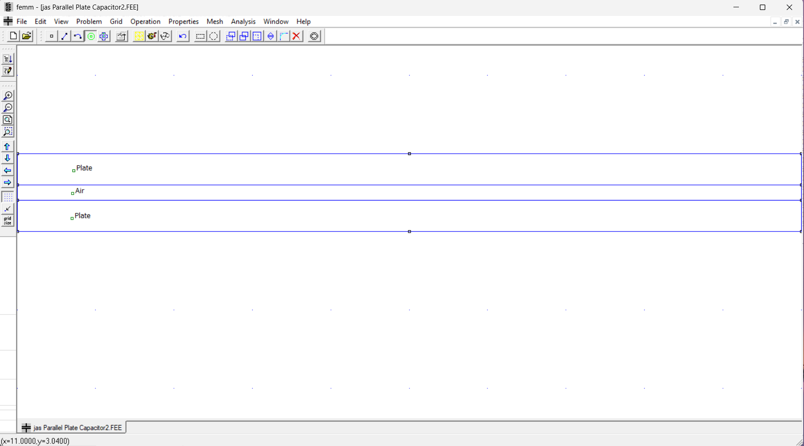
Figure 6: Parallel-Plate Capacitor Construction in FEMM.

- Select Mesh Create Mesh, followed by solving the problem followed by Analysis Analyze, and Analysis View Results. Creating the mesh and analyzing the problem and viewing the results can also be accomplished by the icons. (Note: Inadvertently adding extra Block labels is easy to do when clicking around the model development window, which results in the error “Material properties have not been defined for all block labels. Cannot analyze the problem” when trying to simulate your model. One way to find these inadvertent Block labels so they can be deleted is to click on the Zoom extents icon to include all Block labels. )
- From the top menu, select View Density Plot, which opens a dialog box. Check the Show Density Plot and Show Legend in the dialog box. Viewing the results produces a (Postprocessor) window with several analysis features.
- Click on the capacitor symbol on the top toolbar to open the Conductor Properties pane that includes the voltage and charge of all the defined conductors. Select the Top Plate to display the charge on the top conductor for a voltage difference of 1 V between the plates. Based on the relationship Q = CV, the capacitance of the capacitor equals the charge when the applied voltage is 1 V. Record the capacitance in Table 1 below in the row corresponding to an air dielectric (ε_{r} = 1) and click on OK in the Conductor Properties pane to close the pane.
- Select the Point mode in the (Postprocessor) analysis window.
- Left mouse click somewhere in the dielectric region to see the FEMM Output results pane for that particular point.
- Record the corresponding ∣D∣ and ∣E∣ values from the FEMM Output pane in Table 1 below in the row corresponding to an air dielectric, including units.
- Take a screen shot of your FEMM Parallel-Plate Capacitor Analysis (Postprocessor) Window that includes the Conductor Properties pane and annotate your name, which needs to be done outside of FEMM in an application like Power Point or Word, and then replace Figure 7 below with your version. (8 points.)
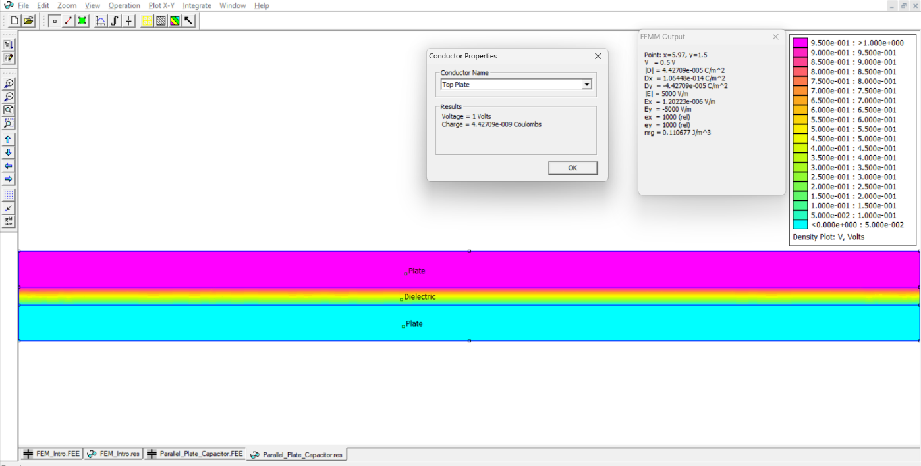
Seth Ricks

Figure 7: Annotated Parallel-Plate Capacitor Analysis (Postprocessor) Window.

- Enable the Contour mode from the top toolbar and right mouse click on the center point (node) along the top edge of the top plate and then right mouse click directly below on the center point (node) along the bottom edge of the bottom plate to form a line contour as denoted by a red line between the selected points. (The Escape key removes contour lines as needed.)
- Select the x-y Plot icon from the top toolbar to open the X-Y Plot of Field Values dialog box. Choose V (Voltage) as the Plot Type and check the Write data to text file option in the dialog box to save the x-y plot data for import into MATLAB. (Note: Do not include spaces in your text file name, as spaces in the filename are incompatible with the MATLAB file read functions.)
- Again, select the x-y Plot icon from the top toolbar and in the X-Y Plot of Field Values dialog box choose ∣E∣ (Magnitude of field intensity) and Check the Write data to text file option.
- Next you are to import your data into MATLAB and produce a 2-pane subplot of your simulation results as shown below in Figure 8.
- For the first subplot, i.e., subplot(2, 1, 1), plot the Voltage versus Distance below the top plate as shown below in Figure 8. For your first subplot, include an x-axis label of “Distance Through the Parallel Plate Capacitor (mm)” using the xlabel() function. Include a y-axis label of “Voltage (V)” using the ylabel() function. Also add a title of “Voltage Profile with 1 V Difference Between the Top and Bottom Plates – Your Name”. Add the following ylim([0, 1.2]) statement to scale the y-axis more favorably.
- For your second subplot, i.e., subplot(2, 1, 2), plot the Electric Field Magnitude versus Distance below the top plate, as shown below in Figure 8.
- Include an x-axis label of “Distance Through the Parallel Plate Capacitor (mm)”. Include a y-axis label of “Electric Field Magnitude (V/m)”. Also add a title of “Electric Field Magnitude Profile with 1 V Difference Between the Top and Bottom Plates”. For the Electric Field Magnitude trace use a trace color different than the color used for the Voltage trace used in the first subplot. Add the following ylim([0, 500]) statement to scale the y-axis more favorably.
- In the MATLAB plot pane, Insert Double Arrow and Insert TextBox to annotate the 2nd subplot with double arrows and text labels indicating the Top Plate, Dielectric and Bottom Plate regions as illustrated below in Figure 8. Replace Figure 8 below with your version. (11 Points.)
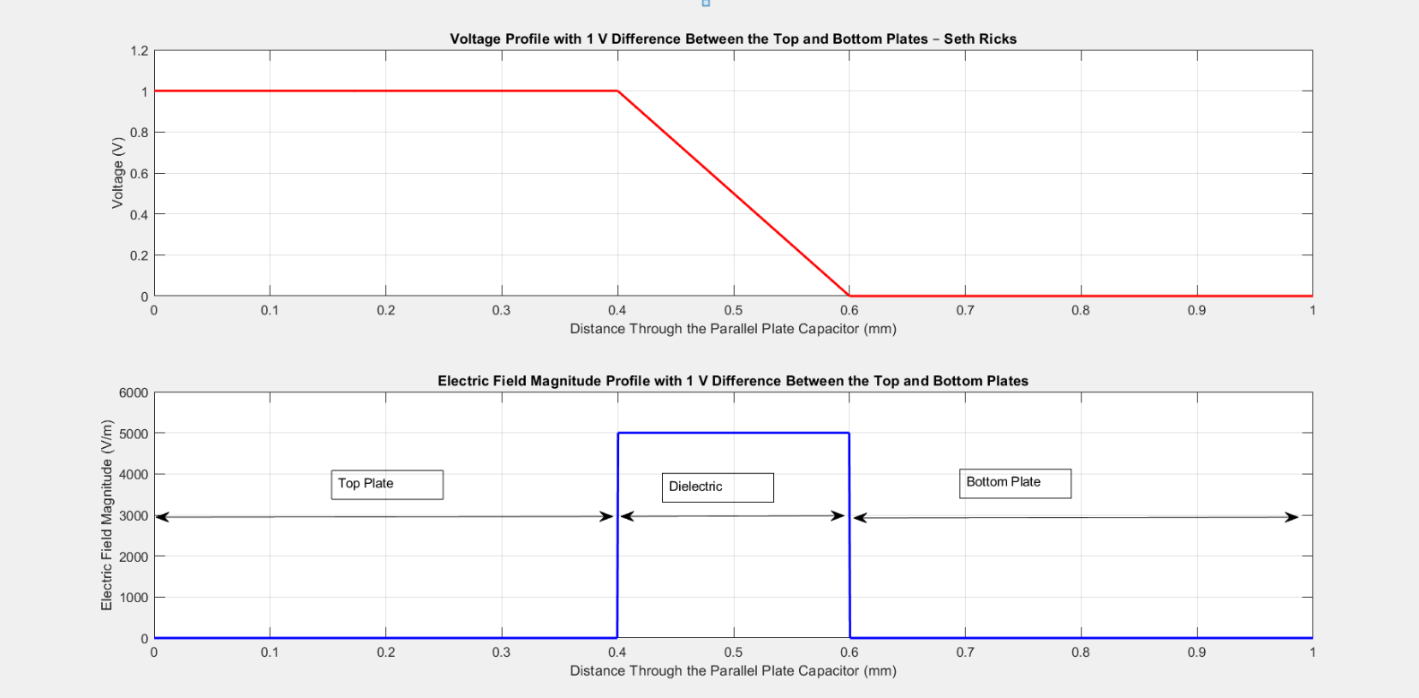
Figure 8: Parallel-Plate Capacitor Voltage and Electric Field Magnitude Profiles.

- Next close the (Postprocessor) analysis window go back to the model development window, selecting Properties Materials Dielectric Modify Properties to open the Block Property dialog box. Change both the x and y relative permittivity values from 1 to 1000 and re-run the simulation.
- Click on the capacitor symbol on the top toolbar in the resulting (Postprocessor) analysis window to open the Conductor Properties pane that includes the voltage and charge of all the defined conductors. Select the Top Plate to display the charge on the top conductor for a voltage difference of 1 V between the plates. Record the capacitance in Table 1 below in the row corresponding to a dielectric with a relative permittivity of 1000 and click on OK in the Conductor Properties pane to close the pane.
- Select the Point mode in the (Postprocessor) analysis window.
- Left mouse click somewhere in the dielectric region to see the FEMM Output results pane for that particular point.
- Record the corresponding ∣D∣ and ∣E∣ values from the FEMM Output pane in Table 1 below in the row corresponding to a relative permittivity of 1000.
- Be sure to include units on all your Table 1 entries. (6 points.)

Table 1: Simulated Parameters for the Capacitor with Dielectric with 1 V Applied.
Relative Permittivity ε_{r} | |E| | |D| | Capacitance C
1.0 | 5000 V/m | 4.42709e-008 C/m² | 4.42709e-012 F
1000 | 5000 V/m | 4.42709e-005 C/m² | 4.42709e-009 F

Discussion and Conclusions Questions: (Note: For the following questions use your own words along with complete sentences. Points are to be deducted for AI generated answers.)

- What does your Figure 5 plot indicate about the magnitude of an electric field inside an ideal conductor? (2 points.)
According to the plot of Electric Field Magnitude vs distance from the center of the cable, the center of the cable (0 mm) has an electric field of 0 V/m. This means that there are no electric fields at the center of the cable.

- What does your Figure 8 plot indicate about the magnitude of the electric field across the dielectric of a parallel-plate capacitor? (2 points.)
According to the plot of electric field vs distance through the parallel plate capacitor, the magnitude of an electric field across the dielectric is constant, in this case 5000 V/m.

- Physically, what causes the capacitance of a parallel plate capacitor increase with increasing relative permittivity ɛ_{r} as indicated in Table 1? (Hint: Permittivity refers to the amount of polarization when exposed to an electric field.) (4 points.)
When the permittivity of the dielectric is increased, it polarizes more when exposed to an electric field. This means that there are more dipoles in the dielectric. The positive dipole is pointing toward the negative side of the applied voltage, so it helps cancel out some of the electric field caused by the accumulating electrons. The more positive dipoles there are, the more charge can accumulate on the plate for the same applied voltage, meaning the capacitance goes up.

- Using the equation C = (ε_{r}ε₀A/d), calculate the relative permittivity of a capacitor dielectric that results in a capacitance of 115 pf for a parallel plate capacitor with a plate area of 10 mm X 10 mm, a plate thickness of 0.4 mm and a plate spacing of 0.2 mm, like the capacitor simulated in Part 2 of this lab. Include at least two steps of your work below. (3 points.)

$$C=\frac{ϵ_{r}ϵ_{0}A}{d}$$
$$ϵ_{r}=\frac{Cd}{ϵ_{0}A}=\frac{\left(115*{10}^{-12}F\right)\left(0.2*{10}^{-3}m\right)}{\left(8.85*{10}^{-12}\frac{F}{m}\right)\left(100*{10}^{-6} m^{2}\right)}=25.99$$
$$ϵ_{r}=25.99$$

FEMM Introduction Lab Grading Rubric: Note: This is a CAD lab to be done individually, rather than in teams, although please help each other out if/when opportunities arise, avoiding plagiarism. Submit an electronic version of a lab report to receive credit for doing this lab. The goal of your lab report is to provide sufficient documentation so that others could re-create your results. Therefore, simply add to this document to arrive at your lab report, as all of the explanatory text, procedures and Discussion and Conclusion questions contained in this document are required for a complete lab report. So for your lab report, add a cover page, your results, along with your answers to the Discussion and Conclusions questions to the existing lab document. Your answers to the Discussion and Conclusions questions are to be uniquely yours and not a copy of someone else’s answers to these questions. Your cover page is to include class, lab title, and author. The following rubric does not need to be included in your lab report.
Lab Items | Points
Cover Page | 1
Part 1 – Coaxial Cable  Figure 4: (10 points total. 3 points for correct looking model geometry, 1 point for including colors by means of the Density Plot, 1 point for including equipotential contours, 1 point for including Electric Field arrows, 1 point for the Conductor Properties pane, 1 point for Voltage = 1 Volts, 1 point for Charge = 1.06e-10 Coulombs, 1 point for including annotated name.)  Figure 5: (10 Points total. 5 Points for subplot(2, 1, 1). 5 Points for subplot(2, 1, 2).) | 20
Part 2 – Parallel Plate Capacitor  Figure 7: (8 points total. 3 points for correct looking model geometry, 1 point for including colors by means of the Density Plot, 1 point for the Conductor Properties pane, 1 point for Voltage = 1 Volts, 1 point for Charge = 4.43e-10 Coulombs, 1 point for including annotated name.)  Figure 8: (11 Points Total. 4 Points for subplot(2, 1, 1). 7 Points for subplot(2, 1, 2).)  Table 1: (6 points total. 1 point per entry, -0.5 points per each missing unit.) | 25
Discussion and Conclusions | 11
Grammar and Professionalism | 3
Total | 60
Please give feedback on errors you find in this document.

Part 1 #3/4: Instruct to add inner conductor and outer shield to materials as well, or can’t add them to block labels.

Part 2 #26: change ylim([0, 500]) to ylim([0, 6000])

